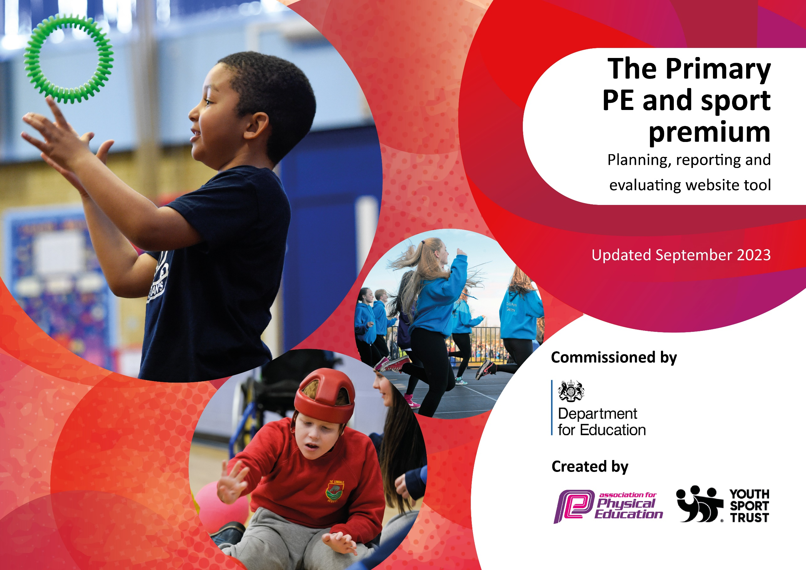

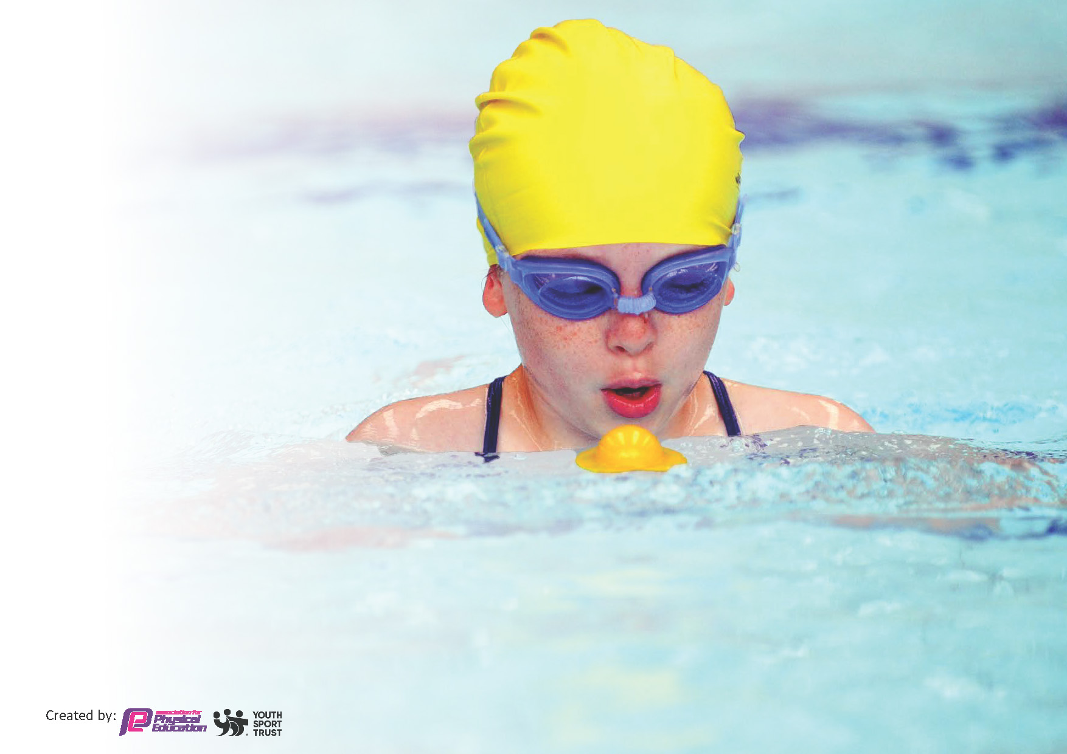
This template can be used for multiple purposes:
by:
- It enables schools to effectively plan their use of the Primary PE and sport premium
- It helps schools to meet the requirements (as set out in guidance) to publish information on their Primary PE and sport premium
- It will be an effective document to support Ofsted inspections enabling schools to evidence progress in Physical Education (PE) and evidence swimming attainment, which forms part of the PE National Curriculum. We would recommend schools consider
the Intent, Implementation and Impact of any spend, as examined within the Education Inspection Framework.

It is important that your grant is used effectively and based on school need.

Schools must use the funding to make additional and sustainable
improvements to the quality of the PE, School Sport and Physical Activity (PESSPA)
they offer. This means that you should use the Primary PE and sport premium to:

- Build capacity and capability within the school to ensure that improvements made now will benefit pupils joining the school in future years
- Develop or add to the PESSPA activities that your school already offers.

The Primary PE and sport premium should not be used to fund capital spend projects; the school’s core budget should fund these. Further detail on capital expenditure can be found in the updated Primary PE and sport premium guidance.

The Primary PE and sport premium guidance, outlines 5 key priorities that funding should be used towards. It is not

necessary that spending has to meet all the key priorities, you should select the priorities that you aim to use any funding towards.

Although completing this template is not a requirement for schools, schools are required to publish details of how they spend this funding. Schools must also outline what the impact this funding has had on pupils’ PE and sport participation and attainment and how any spending will be sustainable in the future. All funding must be spent by 31st July 2024.

The Department for Education has worked closely with the Association for Physical Education (afPE) and the Youth Sport Trust (YST) to develop this template and encourages schools to use it. This template is an effective way of meeting the reporting requirements of the Primary PE and sport premium.
Review of last year’s spend and key achievements (2023/2024)

We recommend you start by reflecting on the impact of current provision and reviewing your previous spend.

Activity/Action | Impact | Comments
Celebration of National Sports Week with a week of sporting workshops, athlete visits and inter-house competitions.  Access a wide range of locality sporting events to provide the children with an opportunity to take part in competitive sports. | The children experienced sports, which we do not cover in our curriculum, e.g. – golf and rugby.  All children took part in over 120 minutes of physical activity per day.  Olympic Gymnast Danusia Francis visited the school – an experience some children may never have had otherwise.  Over 30 sporting fixtures were attended across the year in a wide range of sporting activities. | The children all enjoyed sports week and pupil voice included it being the best week of their school life so far.  Pupil voice was positive regarding the sporting fixtures attended in particular the swimming events.

Key priorities and Planning
This planning template will allow schools to accurately plan their spending.

Action – what are you planning to do | Who does this action impact? | Key indicator to meet | Impacts and how sustainability will be achieved? | Cost linked to the action
Access a wide range of locality sporting events to provide the children with an opportunity to take part in competitive sports.  Identify children performing at a high level and direct them towards appropriate opportunities/competitions.  Replenish PE equipment for lessons and extra-curricular clubs (audit PE provision).  Ensure our grounds are marked and maintained for all children to access. | All pupils | Key indicator 2 -The engagement of all pupils in regular physical activity – the Chief Medical Officer guidelines recommend that all children and young people aged 5 to 18 engage in at least 60 minutes of physical activity per day, of which 30 minutes should be in school.  Key indicator 3 – The profile of PE is raised across the school as a tool for whole school improvement.  Key indicator 4: Broader experience of a range of sports and activities offered to all pupils.  Key indicator 5 – Increased participation in competitive sport. | More pupils meeting their daily physical activity goal.  More pupils accessing a wider range of sporting opportunities. | £600 – transport and fixture costs.  £250  £1500  £400

To celebrate National Sports Week with a week of sporting workshops, athlete visits and inter-house competitions.  National Sports Week WC 17th June 2025 | All pupils. | Key indicator 2 -The engagement of all pupils in regular physical activity – the Chief Medical Officer guidelines recommend that all children and young people aged 5 to 18 engage in at least 60 minutes of physical activity per day, of which 30 minutes should be in school.  Key indicator 3 – The profile of PE is raised across the school as a tool for whole school improvement.  Key indicator 4: Broader experience of a range of sports and activities offered to all pupils.  Key indicator 5 – Increased participation in competitive sport. | Children will have access to sporting opportunities, which we would not normally offer in school.  Olympic athlete visit. | £300  £500 funded by PTA.
Provide high quality coaching of staff to increase their knowledge and understanding.  Continuous Professional Development opportunities shared with staff.  Carry out staff confidence survey.  To monitor the quality of teaching in PE and sports. (Subject leader release time).  Continue to raise the profile of PE/School Sport with staff, all pupils and parents within the school and local community.  Achievements within PE lessons and tournaments are celebrated in worship, newsletters, Instagram and website.  PE coordinator time allocated to print certificates, keep Instagram and website up to date.  Children who attend tournaments receive certificates in assembly.  Continue to use the PE page of the School website to reporting on sporting fixtures.  Pupil attitudinal survey. (Subject leader release time). | All staff.  Whole school community. | Key indicator 1 – Increased confidence, knowledge and skills of all staff in teaching PE and sport.  Key indicator 3 – The profile of PE is raised across the school as a tool for whole school improvement. | Teacher will feel more confident to deliver effective PE supporting pupils to undertake extra activities inside and outside of school.  The profile of school sport will be raised. Children’s achievements will be celebrated and valued. | £9,694  £200  £100 for certificates and trophies  £50  £100  £100  Total – £13,794

Key achievements 2024-2025
This template will be completed at the end of the academic year and will showcase the key achievements schools have made with their Primary PE and sport premium spending.

Activity/Action | Impact | Comments

Swimming Data
Meeting National Curriculum requirements for swimming and water safety.
Priority should always be given to ensuring that pupils can perform safe self-rescue even if they do not fully meet the first two requirements of the National Curriculum programme of study

Question | Stats: | Further context  Relative to local challenges
What percentage of your current Year 6 cohort can swim competently, confidently and proficiently over a distance of at least 25 metres? | 72.7%
What percentage of your current Year 6 cohort can use a range of strokes effectively [for example, front crawl, backstroke, and breaststroke]? | 72.7%

What percentage of your current Year 6 cohort are able to perform safe self-rescue in different water-based situations? | 72.7%
If your schools swimming data is below national expectation, you can choose to use the Primary PE and sport premium to provide additional top-up sessions for those pupils that did not meet National Curriculum  requirements after the completion of core lessons. Have you done this? | Yes/No
Have you provided CPD to improve the knowledge and confidence of staff to be able to teach swimming and water safety? | Yes/No

Signed off by:

Head Teacher: | Iain Campbell
Subject Leader or the individual responsible for the Primary PE and sport premium: | Claire Collins
Governor: | Sarah Elphick – Chair of Governors
Date: | 29.09.24

