British Values in RE

Caring for each other,
Learning from each other,
Achieving with each other...
Guided by God.
Slinfold is a small, inclusive school with strong links to St Peter's Church at the heart of our rural village community. We strive to develop confident, resilient, and compassionate learners by providing an inspiring curriculum. Our supportive and respectful culture, based on our Christian values, enables all to flourish. Through consistently high expectations, challenge and a love of learning we aspire for excellence.
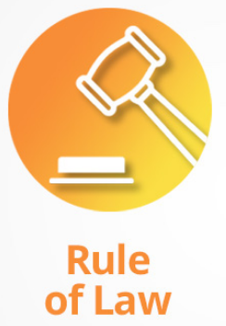 |  |  | 
Mutual Respect
Tolerance of those of different faiths and beliefs
During religious education, when rules for particular faiths are thought about pupils examine different codes for living and consider the value of the rule of law where all people are equal before the law. | During RE lessons we encourage a democratic atmosphere where all pupils have an equal right to be heard and democracy is modelled by the teacher and expected of evert pupil. | Children will learn that religion is a good case study of the balance between individual liberty and the greater good.  It is the right of the parent to withdraw their children from RE. | Children learn about the main religions and are taught respect and understanding for the cultures, beliefs, opinions and traditions of others.  Mutual respect is taught and given when children are expressing their opinions and beliefs.  Children are taught and encouraged to show respect to each other’s beliefs, feelings and opinions by giving each child a form to share these on and an expectation that these must be listened to.  Children consider questions about identify and belonging.  Children learn about the main religions and are taught respect and understanding for cultures, beliefs, opinions and traditions of others.  Collective worship also helps to contribute to the knowledge of special occasions, beliefs and customs.  RE can challenge pupils to be increasingly respectful and to celebrate diversity to different cultures, faiths and beliefs.  Children visit places of worship.

