Topic: Features of Navigation | Strand: Locational Knowledge/Human and Physical Geography
What should I already know? | Vocabulary
- The seven continents and five oceans  - There are different climate zones (e.g. polar regions), and that some zones are hot and dry, some are cold, some are temperate and some are tropical.  - The features of different climate zones, including the biomes found there.  - Human and physical geographical features in different countries, cities and towns.  - How magnets work and that compasses point north.  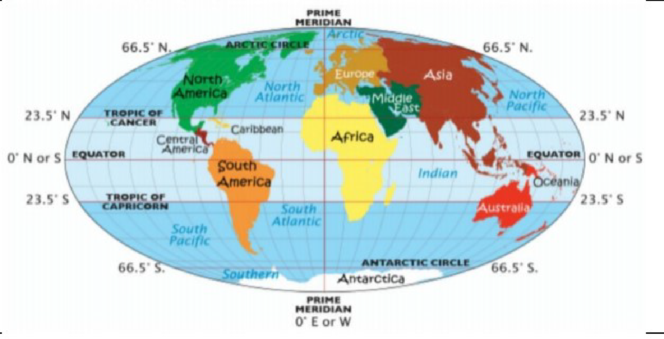  Geographical Skills and Fieldwork  -Use an atlas, maps and globes to locate which countries lie on certain points of the Earth.  - Use the eight points of a compass to describe the locations of countries in relation to one another.  - Compare climate zones and discuss how these are dependent on their location on Earth.  - Use Google Earth to locate countries using coordinates of longitude and latitude.  - Use lines of longitude of latitude to locate major cities around the world.  - Approximate coordinates of other major cities around the world using a world map and knowledge of longitude and latitude.  - Locate two different places; describe their locations using key vocabulary, their human and physical geographical features, their climate (and how their location on Earth affects this), and describe their similarities and differences.  - Research the average temperature or rainfall at different lines of latitude and plot these in a graph. Is there a pattern? | Arctic circle imaginary line drawn around the northern part of the world at approximately 66° North. Arctic winters are long and cold while summers are shortand cool  biome a natural area of the living world which has its own climate, vegetation and animals  climate the general weather conditions that are typical of a place  climate zone sections of the Earth that are divided according to the climate. There are three main climate zones; polar, temperate and tropical.  continent a very large area of land that consists of many countries. Europe is a continent.  degrees a unit of measurement that is used to measure angles  equator an imaginary line around the middle of the Earth at an equal distance from the North Pole and the South Pole.  human geography features of land that have been impacted by human activity  humid a climate that is very hot and damp  Greenwich borough of Greater London, England, located on the prime meridian  latitude latitude of a place is its distance from the equator  longitude longitude of a place is its distance to the west or east of a line passing through Greenwich.  Northern Hemisphere that half of the globe lying north of the equator  ocean one of the five very large areas of salt water on the Earth's surface.  physical geography natural features of land  prime meridian prime meridian is the line of longitude, corresponding to zero degrees and passing through Greenwich, England, from which all the other lines of longitude are calculated.  Southern Hemisphere that half of the globe lying south of the equator  temperate a place which is never extremely hot or extremely cold  time zone one of the areas into which the world is divided where the time is calculated as being a particular number of hours behind or ahead of GMT (Greenwich Mean Time)  tropics parts of the world that lie between two lines of latitude, the Tropic of Cancer, 23½° north of the equator, and the Tropic of Capricorn, 23½° south of the equator. The tropics have a humid climate, where the weather is hot and damp.

