|  |  |
| --- | --- |
| **Vocabulary** | |
| city | a large town. London is a city. |
| compass  point | any of the [main](https://www.collinsdictionary.com/dictionary/english/main) points of a compass: north, south, east and west |
| continent | a very large area of land that consists of many countries. Europe is a **continent**. |
| country | an area of land that is controlled by its own government. |
| England | a country in the **United Kingdom**. Haywards Heath is a t**own** in **England**. |
| island | a piece of land that is completely **surrounded** by water |
| Great  Britain | An **island** that is made up of **England**, Scotland and Wales. |
| ocean | one of the five very large areas of salt water on the Earth's surface. |
| sea | a large area of salty water that is part of an **ocean** |
| surrounded | to be present all around |
| United  Kingdom | The **UK**, is officially known as the United Kingdom of Great Britain and Northern Ireland. It includes **England**, Scotland, Wales and Northern Ireland. |
| village | a small group of houses, perhaps with a few shops, that are often in the countryside. Lindfield is a **village**. |

|  |  |  |  |
| --- | --- | --- | --- |
| **Facts about the continents (ordered by size)** | | | |
| **Continent** | **Surrounded** by these **oceans** | Number of  **countries** | Example of a **country**  that can be  found there |
| Asia | Arctic  Indian  Pacific | 50 | India |
| Africa | Atlantic  Indian | 54 | Kenya |
| North America | Arctic Atlantic  Pacific | 23 | United States of  America |
| South  America | Atlantic  Pacific | 12 | Brazil |
| Antarctica | Southern | - | - |
| Europe | Atlantic  Arctic | 51 | United  Kingdom |
| Australia | Indian  Pacific | 14 | Australia |

|  |
| --- |
| **What should I already know?** |
| * The **country** I live in is called **England**. * I live in Haywards Heath which is a **town** in **England.** * **England** is a country in the United Kingdom (**England,** Scotland, Wales and Northern Ireland). * **Great Britain (England,** Scotland, Wales) is an **island**—it is   **surrounded** by **seas**:   * + Irish Sea   + North Sea   + English Channel |

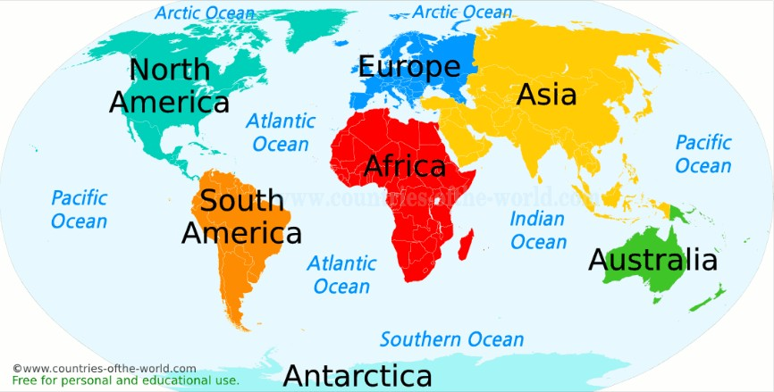

UK

also known as

Australasia or Oceania

* There are seven **continents:**
  + Europe
  + Asia
  + Africa
  + North America
  + South America
  + Antarctica
  + Australasia (Oceania)

**Continents**

* There are five **oceans:**
  + Pacific **Ocean**
  + Atlantic **Ocean**
  + Indian **Ocean**
  + Southern **Ocean**
  + Arctic **Ocean**

**Oceans**

* Find the five **oceans** and seven **continents** using map skills. Can you also find them in an atlas and on a globe?
* Use Google Earth to find Haywards Heath. Zoom out until you see the UK. Now zoom out until you see Europe. Now zoom out until you can see the world. Discuss what you notice.
* Use the **compass points** to describe the **continents** in relation to each other (e.g. Asia is to the east of Europe and to the north of Australia).

**Geographical Skills and Fieldwork**

* Haywards Heath is a **town** in the **country** of **England**. **England** is in the **United Kingdom.**
* The **United Kingdom** is a **country** in the **continent** of Europe.

**Where do I live?**